19/11/2019

Task:

* Plot raw data in python using library matplotlib
* Read from serial in python

Issue: Interpreted results from the accelerometer on putty terminal is not the best approach.

Solution: Use serial interface while WIFI is not implemented to interpret results from the sensor and test DSP algorithm.

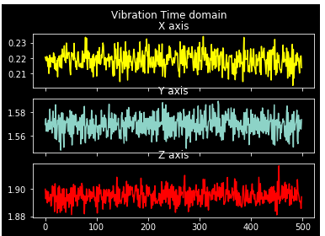

References

https://pyserial.readthedocs.io/en/latest/shortintro.html

<https://maker.pro/pic/tutorial/introduction-to-python-serial-ports>

<https://matplotlib.org/>

https://www.geeksforgeeks.org/python-introduction-matplotlib/